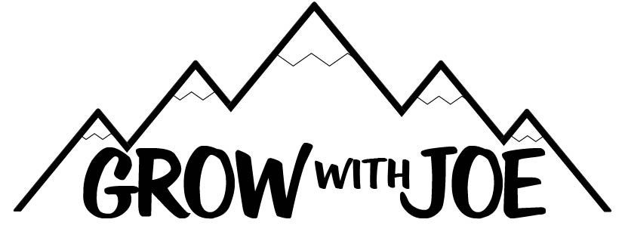

The Top 20 Podcasts To Change Your Mindset

- James Altucher: 391 - Yuval Noah Harari: Are You Imagining The Future Correctly?

- James Altucher: 276 - Scott Adams: The Hardest Sell: Convincing Someone You're Not What You Used to Be

- The Jordan Harbinger Show: 6: Simon Sinek: What's Your "Why" and Where Do You Find It?

- The Jordan Harbinger Show: 70: Alex Kouts: The Secrets You Don't Know About Negotiation Part One

- Noah Kagen Presents: How to Have More Engaging Conversations - With Jordan Harbinger

- Noah Kagen Presents: Deep dive on Jim Rohn's 7 Strategies for Wealth & Happiness

- Radio Lab: Cities

- Radio Lab: Blame

- Freakonomics: 356: America's Hidden Duopoly

- Freakonomics: 347: Why You Shouldn't Open A Restaurant

- The Tai Lopez Show: 390: 17 Ways to Motivate Yourself and Overcome Procrastination

- The Tai Lopez Show: 344: Why Your Mindset Is Your Only Limitation

- Impact Theory with Tom Bilyeu: Jay Shetty On How to Find Your Purpose
- Impact Theory With Tom Bilyeu: David Goggins on How to Become A Savage & Live On Your Own Terms

- Impact Theory With Tom Bilyeu: Tail Lopez on Why Grinding Isn't Enough

- Big Questions with Cal Fussman: Kobe Bryant: Storytelling and the Awareness of Fear

- Big Questions with Cal Fussman: Jocko Willink: On Going to War with Your Weakness

- Big Questions with Cal Fussman: Jim Kwin On Never Forgetting a Name Again

- Marketing Secrets Show: The Hook, The Story, and The Offer

- Marketing Secrets Show: Create Attraction, Connection & Overcome Insecurity - Part 1 of 3

