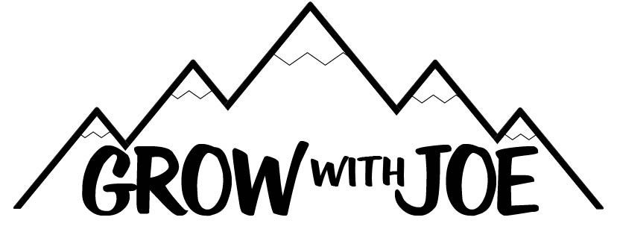

The Top 20 Videos To Motivate You

- Neil Gaiman - Inspirational Commencement Speech at the University of the Arts 2012

- J.K. Rowling Speaks at Harvard Commencement

- When ideas have sex | Matt Ridley

- Steve Jobs' 2005 Stanford Commencement Address(56) Steve Jobs' 2005 Stanford Commencement Address - YouTube

- Richie Parker - ESPN Video

- The art of asking | Amanda Palmer

- University of Texas at Austin 2014 Commencement Address - Admiral William H. McRaven

- Choose yourself | James Altucher | TEDxSanDiego

- The power of vulnerability | Brené Brown

- "You Will FAIL in Your COMFORT ZONE!" | Steve Harvey

- "Put Yourself OUT There, 10X Your LIFE!" | Grant Cardone (@GrantCardone)

- Warren Buffet's Life Advice Will Change Your Future (MUST WATCH)

- THE Greatest Speech Ever by Oprah Winfrey

- Will Smith - Don't Let Anyone Tell You That You Can't…

- The secret of self motivation One of the best speeches Ever (Mel Robbins)

- One of the Greatest Speeches Ever | Jeff Bezos

- Seth Godin's Most Inspiring Speech on Fulfillment! | Raw Impact

- Richard Branson's MOTIVATIONAL SPEECHES

- Tyra Banks Interview - Tyra Banks's Top 10 Rules For Success

- You Will Never Be Lazy Again - Jim Kwik

